IRIS TUMOR DETECTION USING CNN

ABSTRACT

Iris tumors, so called intraocular tumors are kind of tumors that start in the iris; the colored part of the eye that surrounds the pupil. There is a need for an accurate and cost-effective iris tumor detection system since the available techniques used currently are still not efficient. The combination of the image processing different techniques has a great efficiency for the diagnosis and detection of the iris tumor. Image processing techniques improve the diagnosis of the tumor by enhancing the quality of the images, so the physicians diagnose properly. Moreover, using some techniques such as edge detection and image fusion helps in detecting and segmenting the tumor, located in the iris. This paper aims to develop a detection system that automatically detects the presence of abnormalities or tumors in the iris. The suggested system combines different image processing techniques such as image filtering, images adding, canny edge detection, and image fusion. These methods are used in order to analyze and segment the tumor into the iris, and then mark this abnormal region onto the original grayscale image. The iris images are obtained from a public database available on the internet, “Miles Research”. The computer experimental results proved that the proposed detection system can successfully segment an iris tumor, and mark it to be then superimposed on the original image using image fusion.

TABLE OF CONTENTS

CHAPTER NO |  | TITLES | PAGE NO
 |  | ABSTRACT | ii
1 | 1.1 | INTRODUCTION | 1
 | 1.2 | OBJECTIVE | 3
 | 1.3 | IRIS TUMOR DETECTION SYSTEM (ITDS) | 3
 |  | 1.3.1 Grayscale conversion | 5
 |  | 1.3.2 Smoothing using median filtering | 6
 |  | 1.3.3 Background extraction | 6
 |  | 1.3.4 Adding images | 7
 |  | 1.3.5 Image intensity adjustment | 8
 |  | 1.3.6 Segmentation using canny edge detection | 8
 |  | 1.3.7 Removing unwanted components | 9
 |  | 1.3.8 Image fusion | 9
 | 1.4 | THE HUMAN IRIS | 10
 | 1.5 | IRIS DETECTION | 11
 | 1.6 | IRIS RECOGNITION SYSTEM | 11
 |  | 1.6.1 Image Acquisition | 12
 |  | 1.6.2 Iris Segmentation | 12
 |  | 1.6.2.1 Hough Transformation | 13
 |  | 1.6.3 Normalization | 14
 |  | 1.6.3.1 Daugman's rubber-sheet model | 14
 |  | 1.6.4 Feature Extraction | 14
 |  | 1.6.5 Classification | 15
 |  | 1.6.5.1 Support Vector Machine | 15
 | 1.7 | CNNs-CONVOLUTIONAL NEURAL NETWORKS | 16
 | 1.8 | CNNs FOR IRIS RECOGNITION IN THE LITERATURE | 19
 | 1.9 | METHODS - OFF-THE-SHELF CNN FEATURES FOR IRIS RECOGNITION | 20
 | 1.10 | IRIS SEGMENTATION | 23
 |  | 1.10.1. Iris Circular Boundary Detection without Eyelid and Eyelash Detection | 24
 |  | 1.10.2. Iris Circular Boundary Detection with Eyelid and Eyelash Detection | 24
 |  | 1.10.3. Active Contours for Iris Segmentation | 25
 |  | 1.10.4. Region Growing/Watershed-Based Iris Segmentation Methods | 26
 |  | 1.10.5. CNN for Iris Segmentation | 26
 | 1.11 | IRIS SEGMENTATION USING IRIS DENSENET | 27
 |  | 1.11.1. IrisDenseNet Dense Encoder | 29
 |  | 1.11.2. IrisDenseNet Decoder | 30
 | 1.12 | ETDS:EYE TUMOUR DETECTION SYSTEM | 31
 |  | 1.12.1. Image Filtering | 31
 |  | 1.12.2. Morphological operations | 32
 |  | 1.12.3. Image Addition | 33
 |  | 1.12.4. Image Adjustment | 33
 |  | 1.12.5. Edge Detection Based Segmentation | 34
 |  | 1.12.6. Image Fusion | 34
 | 1.13 | IETDS:INTELLIGENT EYE TUMOUR DETECTION SYSTEM | 35
 | 1.14 | MODULES | 36
2 |  | LITERATURE SURVEY | 38
 | 2.1 | EXISTING SYSTEM | 39
 |  | 2.1.1 Disadvantage of existing system | 39
 | 2.2 | PROPOSED SYSTEM | 40
 |  | 2.2.1 Advantage of proposed system | 40
 | 2.3 | FEASIBILITY STUDY | 41
 |  | 2.3.1 Economical feasibility | 41
 |  | 2.3.2 Technical feasibility | 42
 |  | 2.3.3 Operational feasibility | 42
3 |  | SYSTEM SPECIFICATIONS | 43
 | 3.1 | HARDWARE REQUIREMENT | 43
 | 3.2 | SOFTWARE REQUIREMENT | 43
4 |  | SYSTEM DESIGN AND DEVELOPMENT | 44
5 |  | TESTING AND IMPLEMENTATION | 45
 | 5.1 | TESTING | 45
 |  | 5.1.1 Unit testing | 45
 |  | 5.1.2 Block box testing | 45
 | 5.2 | SYSTEM IMPLEMENTATION | 45
6 |  | CONCLUSION | 46
 |  | REFERENCES | 47

CHAPTER 1

  - INTRODUCTION

The eye is structured as follows: the sclera which is the white part. The iris: the black part of the eye excluding the pupil which is the black part into the iris. Eye cancer can be defined as an anarchical growth of abnormal cells. This may be produced in or around the eye and then develop into a mass (tumor). A tumor is a mass of tissues formed by an uncontrolled growth of cells. There are different types of eye tumors, and each type can affect certain parts of the eye. The eye tumor can be called as ocular which is the medical name of the eye. It can be intraocular, means inside the eye or extraocular which means that it affects the outside part of the eye. The most common types of the intraocular iris tumors are the Cyst, Nevus, and Melanoma. The cyst is a benign tumor that takes place inside the stroma; the front of the iris, or in the iris pigment epithelium; the back of the iris. Nevus is a benign pigmented growth iris tumor featured as yellow spots in the iris. It can be around the iris or beneath the retina. Nevus has a rare malignancy transformation into ocular melanoma; a cancer of the eye. The melanoma is a malignant tumor that can start in the skin or in the lining of the eye. The melanoma often grows and develops in the tissues in the middle layer of the eyeball. This middle layer is called the uvea and contains the iris. This iris tumor has many signs and symptoms such as the dark spots in the iris area, the change in size or even the shape of the pupil, and the changes in the vision and other signs. Since our system is an image processing system, which stimulates the human vision, so it can detect the first two signs which are the dark spots and the change in the size and shape of the three discussed iris tumors. The proposed system aims to automatically detect the tumor into the iris region.
Biometric technology is concerned with recognizing the identity of individuals based on their unique physical or behavioral characteristics. The physical characteristics such as iris, face, fingerprint, retina, vein and hand geometry or the behavioral characteristics such as hand writing, human gait, signature, and keystrokes have unique, accurate and stable information about a person to be used in authentication applications. The growing developments in information technology have made it possible to use biometrics in applications where it is required to establish or confirm the identity of individuals. Now a day, the increasing demand for enhanced security in the daily life towards the digitalization has directed the improvement of the reliable and intelligent person identification system based on biometrics. The cards or passwords are used in traditional identification systems. This traditional system may be broken down by losing or stealing cards and failing to remember password. That is why biometric identification systems that can identify humans without depending on what person possesses or what person remembers is badly needed. Applications such as passenger control in airports, access control in restricted areas, border control, database access and financial services are some of the examples where the biometric technology has been applied for more reliable identification and verification. The biometric technology, in the field of financial services, has shown a great potential in offering more comfort to customers while increasing their security. For an example, banking services and payments based on biometrics are going to be much safer, faster and easier than the existing methods based on credit and debit cards. Although there are still some concerns about using biometrics in the mass consumer applications due to information protection issues, it is believed that the technology will find its way to be widely used in so many different applications. The biometric technologies provide more secure than the use of passwords and comfortable accessibility and have dealt with problems such as forgetting or hacking passwords.
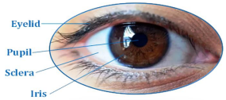
The outer structure of human iris
1.2 OBJECTIVE
The purpose of this project will be to implement an iris recognition and identification system which can authenticate the claimed performance of the methodology. The development tool used will be MATLAB®, and emphasis will be only on the software for exhibiting recognition, and not hardware for capturing an eye image. MATLAB® provides an excellent RAD(Rapid Application Development) environment, with its image processing toolbox, and highlevel computing techniques. Two sets of eye images from different databases are considered to confirm the certainity of system programming. The two database being:
- CASIA: a database of 756 greyscale eye images courtesy of The Chinese Academy of Sciences – Institute of Automation, and
- LEI: a database of 120 digital greyscale images courtesy of the Lion’s Eye Institute.

1.3 IRIS TUMOR DETECTION SYSTEM (ITDS)
In this paper an iris tumor detection system is developed. The system is implemented using Matlab programing language (Matlab 2013 software tools). ITDS is based on different image processing techniques used in order to stimulate the human visual inspection for detecting the iris tumor into an eye. The eye images are obtained from “Miles research”; a public database available on the internet.
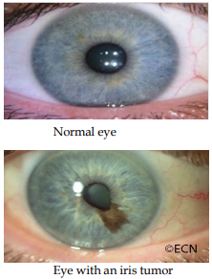

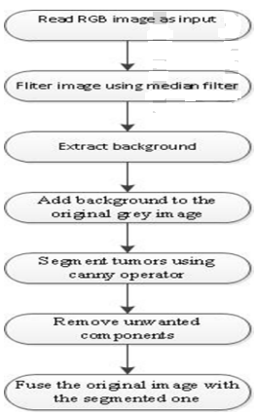
Flowchart of the proposed algorithm
The images are converted first to grayscale images, and then these images are filtered using median filter in order to enhance their quality. The background image is extracted in order to be then substracted from the original one. Image adjustment is applied to the resulted image, thus increases its pixels intensity which clears that area that is then segmented in the next step, the edge detection using canny operator.
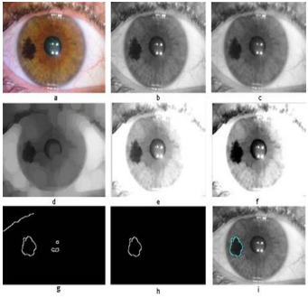
Iris melanoma (a) the original RGB image, (b) the grayscale image, (c) the median filtered image, (d) the extracted background, (e) the added image: original + background, (f) the adjusted image, (g) the segmented region of interest using canny edge detection, (h) ROI after removing unwanted components, (i) superimposing the ROI on the original grayscale image using image fusion
After extracting the region of interest, the unwanted components are removed using an algorithm. The last method is to superimpose the extracted ROI on the original grayscale image using image fusion in order to mark the tumor region onto the original image. The flowchart below shows our proposed system algorithm by setting successively the methods used. our proposed iris tumor detection system, in which an iris melanoma image undergoes all previously discussed image processing techniques in order for the tumorous area to be segmented and then to mark the region of interest on the original grayscale image using image fusion.

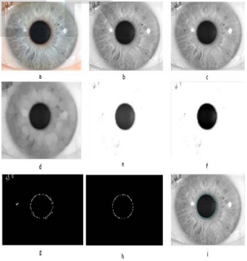
Normal Iris (a) the original RGB image, (b) the grayscale image, (c) the median filtered image, (d) the extracted background, (e) the added image: original + background, (f) the adjusted image, (g) extracted region of interest using canny edge detection (iris), (h) ROI after removing unwanted components, (i) fused image.

1.3.1 Grayscale conversion
The first step is to convert the RGB image to grayscale. This conversion is done using the luminosity method which relies on the contribution of each color of the three RGB colors. Using this method, the grayscale image is brighter since the colors are weighted according to their contribution in the RGB image not averagely.
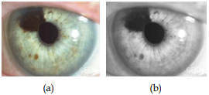
(a) RGB image of an eye with iris tumor, (b) Grayscale converted image of (a)
1.3.2 Smoothing using median filtering
A smoothing filter is mainly used to reduce noise in an image. In a specific pixel, it takes into consideration the neighbor pixels to that studied pixel. The pixels are filtered out and the noise is reduced by taking the neighboring pixels into account. One of the most useful filters used for smoothing images is the median filter. This type of filters is used to reduce impulsive noise or the salt-and pepper in an image with preserving the useful features and image edges. Median filtering is a linear process in which the output of the being processed pixel is found by calculating the median of a window of pixels that surrounds that studied pixel.
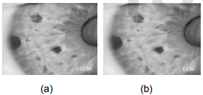
(a) Grayscale image before median filtering, (b) Grayscale image after median filtering
1.3.3 Background extraction
Morphological operations are used for the extracting of background. Morphology can be defined as set of image processing operations that process images based on shapes [8]. These operations can be done by applying a structuring element to an input image, resulting in an output image of the same size. The structure element is a matrix consists of 0’s and 1’s, where the 1’s are called the neighbors. The value of each pixel in the output image is set according to a comparison of the corresponding pixel in the input image with its neighbors. Structure element has many shapes according to its application. Here, the “disk” structure element with a “radius” of 15 is used to extract the background. The most common morphological operations are erosion and dilation. The latter is used to respectively remove or add a pixel at object boundary based on structuring element shape and radius. The formula of finding the output pixel in both operations is the maximum of input pixels neighborhood matrix. Image opening is used to extract background in the proposed system. Morphological opening is erosion followed by dilation using the same structure element for both operations. The opening technique can remove objects that cannot completely contain the structuring element in order then to extract the background.
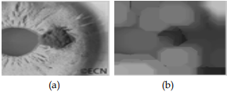
(a) Original grayscale image of iris tumor, (b) Removed background
1.3.4 Adding images
This operation is to add the background image to original grayscale image. Adding two images can be done by adding each pixel in the first image to its corresponding one in the second image. This increases the intensity of pixels, and then the region of interest (cancer area) gets brighter and clearer since the pixels under this region have higher intensities than other pixels. Figure 3(e) shows the result image of adding two images (background and original image). The following equation represents the adding operation. The original iris cancer image is being defined as O(x,y), the background image as B(x,y), and the resulted image as R(x,y). = ∑∑ + )),(),((),( n i m j ji ji yxR yxByxO (1) Where i and j represent the rows and columns respectively. O(xi,yj) and B(xi,yj) are the elements values of the original and background images matrices. The number of elements of both images matrices which should be equal for both images matrices. Figure below shows the result image of the adding operations of an original iris tumorous image with its background.
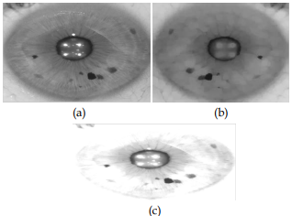
(a) Original grayscale image, (b) Removed background, (c) Added image
1.3.5 Image intensity adjustment
The images then undergo intensity adjustment in which the input image’s intensities are mapped to a new range of in the output image. This can be done by setting the low and high input intensity values that should be mapped and the scale over which they should be mapped.
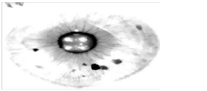
Adjusted image og
1.3.6 Segmentation using canny edge detection
Segmentation is the process of partitioning the image into different and many regions. This process can be done using different methods. The most common method for segmentation is the edge detection using canny operator. The latter is an algorithm used for detecting range of edges in an image. It detects the intensity discontinuities and finds boundaries of objects in an image by classifying pixels into edges. A pixel is classified as pixel if the gradient magnitude of it is greater than those of its both neighbors on the left and right sides.
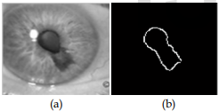
(a) Iris tumor grayscale image, (b) Segmented tumor using canny edge detection
1.3.7 Removing unwanted components
The images then undergo an operation called as area opening. This technique is used to remove the un-wanted components into an image using a matlab function “bwareaopen”. This technique is to remove form a binary image all the connected components (objects) that have pixels lower than than a set value. After applying this technique we could get a result image showing the segmented region of interest (tumor region) for abnormal images and an image with only one circle, the pipil circle; representing the normal image.
1.3.8 Image fusion
For the purpose of superimposing the extracted region of interest onto original grayscale image we use a technique called image fusion. This image processing technique is a process of superimposing or combining relevant information from two or more images into a single output image in order to come up with a more informative image. Image fusion can be categorized into three categories: pixel level, feature level, and decision level. In our proposed system we use the pixel level fusion, in which the input images are fused pixel by pixel followed by the information extraction which is in our case marking the tumor area onto the original grayscale image.
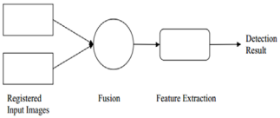
Pixel level image fusion

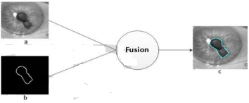
Image fusion (a) original image, (b) Segmented tumor, (c) Fused image
1.4 The Human Iris
Iris is the pigmented region of the eye. It is a circular sinewy diaphragm separating the two regions of the eye. It extends from ciliary muscle across the eyeball in front of the lens. It has a small circular aperture in the middle through which the light enters the eye, which is called pupil. The iris controls the amount of light entering the eye by contracting or relaxing the eye muscle, and hence contracting or dilating the pupil.
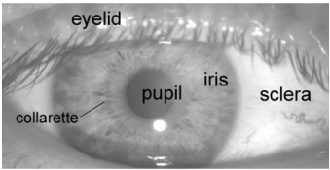
Iris
The particular pattern in the iris region is formed during the elementary term of life, and stromal pigmentation occurs in the following couple of years. The incidental process of formation of the unique patterns of the iris is not related to any genetic factors. The only characteristic that depends on ancestral genes is the pigmentation of the iris, giving eye its color. As a result leading to an autonomously independent pattern of the two eyes of an individual. Furthermore, identical twins acquire non-germane iris patterns.
1.5 Iris Detection
The iris is a well-protected part of the eye, although it is externally visible whose unique self-generated pattern remains stable throughout adult life. These key factors which make the Iris suitable as a biometric for identifying individuals.
Image processing frameworks can be used unique feature and pattern extraction along with converting it into the biometric template from the digital image of the eye, which can be later stored in the database. This biometric template contains a physical-mathematical representation of the unique information stored in the iris and allows comparisons to be made between models. When a client prefers to be distinguished and identified by an iris recognition system:
- The image of eye needs to be acquired and is photographed(Image acquisition),
- A template is generated for eyes’ iris region for biometric identification.
- This template is studied in regard with the other templates stored in a database for comparison until either a matching model is found or no match is detected.
- If a match is recognized, the client is declared identified and acknowledged
- If no match is recognized, the client remains unidentified and anonymous.
1.6 IRIS RECOGNITION SYSTEM
Generally, the iris recognition systems consist of the following steps: (i) image acquisition, (ii) iris segmentation, (iii) normalization, (iv) feature extraction and (v) classification. In this paper, segmentation is achieved using Hough transform for localizing the iris and pupil regions. The segmented iris region is normalized to a rectangular block with fixed polar dimensions using Daugman‟s rubber sheet model. The technique includes CNN and SVM used for feature extraction and classification respectively to increase the performance of the iris recognition.
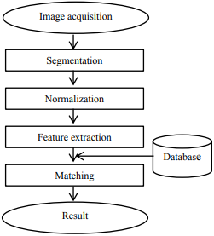
Flow diagram of the system employed in this study
1.6.1 Image Acquisition
The first step of iris recognition is image acquisition deals with capturing sequence of high quality iris images from the subject using cameras and sensors. These images should clearly show the entire eye especially iris and pupil part, and then some preprocessing operation may be applied to enhance the quality of image e.g. Obtain images with sufficient resolution and sharpness. In this paper, CASIA-Iris V4 database is used instead of capturing eye images. CASIAIrisV4 is an extension of CASIA-IrisV3 and contains six subsets. The three subsets from CASIA-IrisV3 are CASIA Iris-Interval, CASIA-Iris-Lamp, and CASIA-Iris-Twins respectively. The three new subsets are CASIA-Iris-Distance, CASIA-Iris-Thousand, and CASIA-Iris-Syn. CASIA-IrisV4 contains a total of 54,601 iris images from more than 1,800 genuine subjects and 1,000 virtual subjects. All iris images are 8 bit gray-level JPEG files, collected under near infrared illumination or synthesized.
1.6.2 Iris Segmentation
The next step of iris recognition is iris segmentation, is a process to isolate the actual iris region in a digital eye image. The iris region, can be approximated by two circles, one for the iris/sclera boundary and another, interior to the first, for the iris/pupil boundary. Hough Transformation is used to locate the circular iris region.
1.6.2.1 Hough Transformation
It is an algorithm used to compute the parameters of the geometric objects (lines and circles) in an image. The circular Hough transform can be used to find the center coordinates and radius of the iris and pupil regions. This technique is generally used to find shapes of the objects by a voting procedure within the classes available. In the segmentation algorithm, an edge map is created by computing the gradients (first derivatives of intensity values) in an eye image. For each edge pixel in the edge map, the surrounding points on the circle at different radii are taken and votes are cast for finding the maximum values that constitute the parameters of circles in the Hough space. The center coordinates and the radius are computed using the following equation: 𝑥𝑐 2 + 𝑦𝑐 2 − 𝑟 2 = 0 (1) The maximum point corresponds to the radius „r‟; the center coordinates (𝑥𝑐 , 𝑦𝑐 ) of the circle are given by the edge points in the Hough space. To perform the edge detection, derivatives (gradients) are taken in the vertical direction for detecting the iris-sclera boundary, in order to reduce the influence of the eyelids that are horizontally aligned. Taking only the vertical gradients for locating the iris boundary will reduce influence of the eyelids when performing circular Hough transform, and not all of the edge pixels defining the circle are required for successful localization. Not only does this make circle localization more accurate, it also makes it more efficient, since there are less edge points to cast votes in the Hough space.
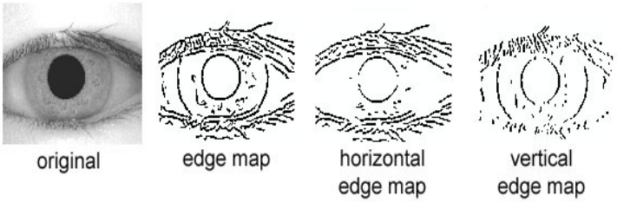
Segmentation using Hough transformation

1.6.3 Normalization
After successfully segmented the iris region from an eye image, the circular iris region is transformed into a fixed size rectangular block. The iris regions, which have the same constant dimensions is produced in the normalization process, so that two photographs of the same iris under different conditions will have characteristic features at the same spatial location. Daugman‟s rubber-sheet model is used here to normalize iris image.
1.6.3.1 Daugman's rubber-sheet model
The most widely used method for iris normalization is Daugman's rubber-sheet model, which converts the iris to a rectangular block over a doubly dimensionless non concentric polar coordinate system. The Daugman‟s rubber sheet model finds for every pixel in the iris, an equivalent position on the polar axes (r,θ) where r is the radial distance and θ is the rotated angle at the corresponding radius. The radial resolution is described as the number of data points in the radial direction while the angular resolution is the number of radial lines generated around the iris region. Using equation 2, 𝐼 𝑥 𝑟, 𝜃 , 𝑦 𝑟, 𝜃 → 𝐼 𝑟, 𝜃 (2) The iris region is transformed to a 2D array with horizontal dimensions corresponding to the angular resolution and the vertical dimension to radial resolution.
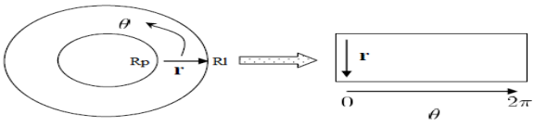
Daugman’s Rubber-sheet Model
Where I(x,y) corresponds to the iris region, (x,y) and (r,θ) are the Cartesian and normalized polar coordinates, respectively. θ ranges from 0 to 2π and r from Rp to Rl . x(r,θ) and y(r,θ)are defined as linear combinations of pupil boundary points.
1.6.4 Feature Extraction
The most important step in iris recognition is feature extraction. Feature extraction is a process of finding the most discriminating information present in an iris pattern. The recognition rate and run time of matching of two iris templates mostly depends on feature extraction technique. In this paper, CNN is used for extracting feature of the normalized iris image.
1.6.5 Classification
The template generated in the feature extraction stage needs a matching metric to measure the similarity between two iris templates. This metric gives one range of values when templates generated from the same eye are compared and another range of values when templates generated from different person‟s eye are compared; so that we can decide as to whether the two templates belong to the same or different persons.
1.6.5.1 Support Vector Machine
Pattern recognition is performed by Support vector machine (SVM) that works on the basis of the principle of structural risk minimization. SVM is treated as binary classifier that separates the two classes of data optimally. The two major aspects of developing SVM as a classifier is: (i) to determine the optimal hyperplane in between two separate classes of data and (ii) to transform the non-linearly separable classification problem into linearly separable problem.
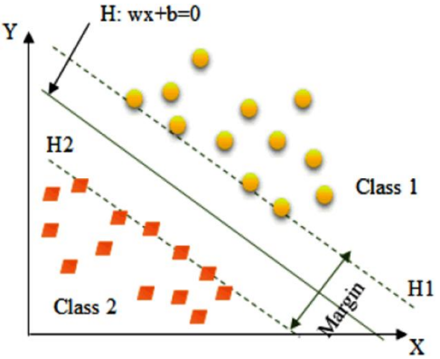
SVM with Linear separable data
Let x is a set of input feature vector and y is the class label. The input feature vectors and the class label can be represented as{𝑥𝑖,𝑦𝑖 }, where i = 1, 2 . . . N and y = ± 1. The separating hyperplane can be represented as follows, 𝑤. 𝑥 + 𝑏 = 0 (5) This implies, 𝑦𝑖 𝑤. 𝑥𝑖 + 𝑏 ≥ 1; 𝑖 = 1,2,3 … 𝑁 (6) {𝑤, 𝑏} can have numerous possible values which create separating hyperplane. It is believed that points often lie between two data classes in such a way that there is always some margin in between them. SVM maximizes this margin by considering it as a quadratic problem. The SVM is used to make two possible decisions during iris recognition; acceptance or rejection of a person.
1.7 CNNs - Convolutional Neural Networks
A specific category of neural networks methods is CNN that has not only been able to learn image feature representations automatically, but they have also outperformed many conventional hand-crafted feature techniques. Neural networks models have a hierarchical representation of data and depend on the computation of layers. NN models have a sequential implementation, which means, the previous layers output will be the next layers input. Every layer gives one representation level and there are a set of weights that parameterized the layers. It is also noted that, the input units linking to output units through the weights in addition to a group of biases. In CNN, the weights are shared locally, which means that each location of the input has the similar weights. The filter form by the weights linked to the similar output. A CNN encompasses alternating layers of locally connected convolutional layers. Every layer has the same number of filters. Down-sampling layers and the fully connected layers work as a classifier. CNN architecture shown in fig 5, is effective because of having three concepts: local receptive fields, weights sharing, and down-sampling operations. The local receptive field means every neuron accepts input from a small portion of the preceding layer. It has also the same size of the convolution filter. Local receptive fields are used in convolutional and down-sampling layers. The weight sharing is applied to the convolutional layer to control the capacity and to decrease the complexity of the model. Finally, the nonlinear down-sampling which used in the down sampling layers to decrease the spatial size of the image as well as decrease the number of the free parameters of the model. With these concepts, CNN is very strong and effective in learning. Moreover the details of the Convolutional Neural Networks layers are:
The Convolutional Layer: the weights in this layer are made of a set of learnable filters produced randomly and learned through the back-propagation algorithm. The feature map is the outcome of every filter that convolved through the entire image. Also, the feature maps have the same number of the applied filters in that layer. the first convolutional layer containing 6 filters that produced 6 feature maps which arranged together. Every feature map represents specific features from the image, for example, represented points, or represented vertical edges. The convolution operation can be described as follows, 𝑥𝑖 𝑙 = 𝑓 𝑥𝑖 𝑙−1 𝑖∈𝑀𝑗 ∗ 𝑘𝑖𝑗 𝑙 + 𝑏𝑗 𝑙 (3) Here j is the specific convolution feature map, Mj is a selection of input maps, kij is the filter, bj is the feature map bias, l is the layer in the CNN, and f is the activation function. The ReLU is the common activation function which used to add non-linearity to the network.
The Pooling Layer: It implements a down-sampling operation to decrease the spatial size of the convolutional layers. First, the size of pooling mask and pooling operation type must be determined and after that applied at the pooling layer. The pooling operation implemented on the pixel values captured by the pooling mask, multiply it by a trainable coefficient, after that added to a trainable bias. The pooling operation can be described as follows, 𝑥𝑗 𝑙 = 𝑓 𝐵𝑗 𝑙𝑝𝑜𝑜𝑙 𝑥𝑗 𝑙−𝑖 + 𝑏𝑗 𝑙 (4) Where 𝑥𝑗 𝑙 is the result of the down-sampling operation applied on the jth region in the input, 𝑥𝑗 𝑙−𝑖 is the jth region of interest captured by the pooling mask in the previous layer, pool is the specific operation done on the region (max or average), 𝐵𝑗 𝑙 is a trainable coefficient, 𝑏𝑗 𝑙 is a trainable bias,and f is an activation function. The max pooling is the most common pooling operation and it is used in this work.
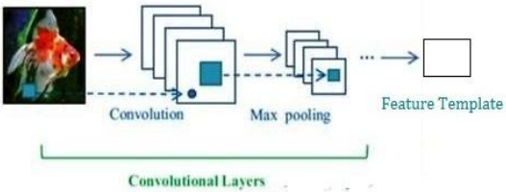
An illustration of the CNN architecture
Deep learning methods, especially convolutional neural networks (CNNs), have recently led to breakthroughs in many computer vision tasks such as object detection and recognition, and image segmentation and captioning. By attempting to mimic the structure and operation of the neurons in the human visual cortex through the use of hierarchical multi-layer networks, deep learning has been shown to be extremely effective in automating the process of learning feature-representation schemes from the training data, thereby eliminating the laborious feature engineering task. CNNs belong to a specific category of deep learning methods designed to process images and videos. By using repetitive blocks of neurons in the form of a convolution layer that is applied hierarchically across images, CNNs have not only been able to automatically learn image feature representations, but they have also outperformed many conventional hand-crafted feature techniques. In the 1960s, Hubel and Wiesel found that cells in the animal visual cortex were responsible for detecting light in receptive fields and constructing an image. Further, they demonstrated that this visual field could be represented using a topographic map. Later, Fukushima proposed the NeoCognitron, which could be regarded as the predecessor of the CNN. The seminal modern CNN was introduced by Yan Lecun et al. in the 1990s for Handwritten Digit Recognition with an architecture called LeNet. Many features of modern deep networks are derived from the LeNet, where convolutional connections were introduced and a backpropagation algorithm was used to train the network. CNNs became exceptionally popular in 2012 when Krizhesky et al. introduced a CNN called AlexNet, which significantly outperformed previous methods on the ImageNet Large-Scale Visual Recognition Challenge (ILSVRC). The AlexNet is simply a scaled version of the LeNet with a deeper structure, but is trained on a much larger dataset (ImageNet with 14 million images) with a much more powerful computational resource (GPUs). Since then, many novel architectures and efficient learning techniques have been introduced to make CNNs deeper and more powerful, achieving revolutionary performance in a wide range of computer vision applications. The annual ILSVRC event has become an important venue to recognize the performance of new CNN architectures, especially with the participation of technology giants like Google, Microsoft and Facebook. The depth of the “winning” CNNs has progressively increased from 8 layers in 2012 to 152 layers in 2015, while the recognition error rate has significantly dropped from 16.4% in 2012 to 3.57% in 2015. Pre-trained CNNs have been open-sourced and widely used in other applications and show very promising performance.
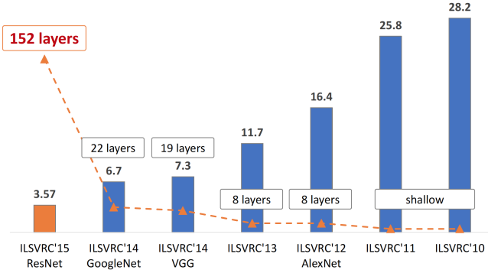
The evolution of the winning entries on the ImageNet Large Scale Visual Recognition Challenge from 2010 to 2015. Since 2012, CNNs have outperformed hand-crafted descriptors and shallow networks by a large margin. Image re-printed with permission
1.8 CNNs for iris recognition in the literature
A number of deep networks have been proposed for improving the performance of iris recognition. Liu et al. proposed a DeepIris network of 9 layers consisting of one pairwise filter layer, one convolutional layer, two pooling layers, two normalization layers, two local layers and one fully-connected layer. This deep network achieved a very promising recognition rate on both the Q-FIRE and CASIA datasets. Gangwar et al. employed more advanced layers to create two Deep Iris Nets for the iris recognition task. The first network, DeepIrisNet-A, contained 8 convolutional layers (each followed by a batch normalization layer), 4 pooling layers, 3 fully connected layers and two drop-out layers. The second network, DeepIrisNet-B, added two inception layers to increase the modeling capability. These two networks exhibited superior performance on the ND-IRIS-0405 and ND-CrossSensor-Iris-2013 datasets. It is worth mentioning that CNNs have also been used in the iris biometrics community for iris segmentation, spoof detection and gender classification. While self-designed CNNs such as DeepIris and DeepIrisNet have shown promising results, their major limit lies in the design of the network since the choice on the number of layers is limited by the number of training samples. The largest public dataset that is currently available is the ND-CrossSensor-2013 dataset which contains only 116,564 iris images. This number is far from the millions of parameters that embody any substantially deep neural network. To deal with the absence of a large iris dataset, transfer learning can be used. Here, CNNs that have been trained on other large datasets such as ImageNet, can be appropriated directly to the iris recognition domain. In fact, CNN models pre-trained on ImageNet, have been successfully transferred to many computer vision tasks. Minaee et al. showed that the VGG model, even though pre-trained on ImageNet to classify objects from different categories, works reasonably well for the task of iris recognition. However, since the release of the VGG model in 2014, many other advanced architectures have been proposed in the literature. In this paper, we will harness such CNN architectures - primarily those that have won the ImageNet challenge - for the iris recognition task.
1.9 METHODS - OFF-THE-SHELF CNN FEATURES FOR IRIS RECOGNITION
Considering the dominance of CNNs in the computer vision field and inspired by recent research which has shown that Off-the-Shelf CNN Features work very well for multiple classification and recognition tasks, we investigate the performance of state-of-the-art CNNs pre-trained on the ImageNet dataset for the iris recognition task. We first review some popular CNN architectures and then present our framework for iris recognition using these CNN Features.
A. CNNs in use
We will now analyze each architecture in detail and highlight their notable properties.
AlexNet: ILSVRC 2012 winner: In 2012, Krizhevsky et al. achieved a breakthrough in the large-scale ILSVRC challenge, by utilizing a deep CNN that significantly outperformed other hand-crafted features resulting in a top-5 error rate of 16.4%. AlexNet is actually a scaled version of the conventional LeNet, and takes advantage of a large-scale training dataset (ImageNet) and more computational power (GPUs that allow for 10x speed-up in training). Tuning the hyperparameters of AlexNet was observed to result in better performance, subsequently winning the ILSVCR 2013 challenge. The detailed architecture of AlexNet is presented in the Appendix. In this paper, we extract the outputs of all convolutional layers (5) and all fully connected layers (2) to generate the CNN Features for the iris recognition task.
VGG: ILSVRC 2014 runner-up: In 2014, Simonyan and Zisserman from Oxford showed that using smaller filters (3 × 3) in each convolutional layer leads to improved performance. The intuition is that multiple small filters in sequence can emulate the effects of larger ones. The simplicity of using small sized filters throughout the network leads to very good generalization performance. Based on these observations, they introduced a network called VGG which is still widely used today due to its simplicity and good generalization performance. Multiple versions of VGG has been introduced, but the two most popular ones are VGG-16 and VGG-19 that contain 16 and 19 layers, respectively. The detailed architecture of VGG is presented in the Appendix. In this paper, we extract the outputs of all convolutional layers (16) and all fully connected layers (2) to generate the CNN Features for the iris recognition task.
GoogLeNet and Inception: ILSVRC 2014 winner: In 2014, Szegedy et al. from Google introduced the Inception v1 architecture that was implemented in the winning ILSVRC 2014 submission called GoogLeNet with a top-5 error rate of 6.7%. The main innovation is the introduction of an inception module, which functions as a small network inside a bigger network. The new insight was the use of 1 × 1 convolutional blocks to aggregate and reduce the number of features before invoking the expensive parallel blocks. This helps in combining convolutional features in a better way that is not possible by simply stacking more convolutional layers.

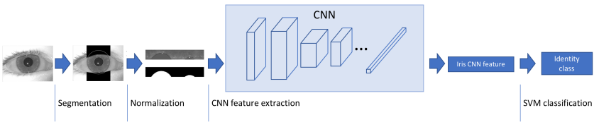
The framework for iris recognition using Off-the-shelf CNN Features. The iris image is segmented using two circular contours and then geometrically normalized using a pseudo-polar transformation resulting in a fixed rectangular image. Features are next extracted using off-the-shelf CNNs, and then classified using an SVM.
Later, the authors introduced some improvements in terms of batch normalization, and re-designed the filter arrangement in the inception module to create Inception v2 and v3. Most recently, they added residual connections to improve the gradient flows in Inception v4. The detailed architecture of Inception v3 is presented in the Appendix. In this paper, we extract the outputs of all convolutional layers (5) and all inception layers (12) to generate the CNN Features for the iris recognition task.
ResNet: ILSVRC 2015 winner: In 2015, He et al. from Microsoft introduced the notion of residual connection or skip connection which feeds the output of two successive convolutional layers and bypasses the input to the next layer. This residual connection improves the gradient flow in the network, allowing the network to become very deep with 152 layers. This network won the ILSVRC 2015 challenge with a top-5 error rate of 3.57%. The detailed architecture of ResNet-152 is presented in the Appendix. In this paper, we extract the outputs of all convolutional layers (1) and all bottleneck layers (17) to generate the CNN Features for the iris recognition task.
DenseNet: In 2016, Huang et al. from Facebook proposed DenseNet, which connects each layer of a CNN to every other layer in a feed-forward fashion. Using densely connected architectures leads to several advantages as pointed out by the authors: “alleviating the vanishing-gradient problem, strengthening feature propagation, encouraging feature reuse, and substantially reducing the number of parameters”. The detailed architecture of DenseNet-201 is presented in the Appendix. In this paper, we extract the outputs of a selected number of dense layers (15) to generate the CNN Features for the iris recognition task. It is worth noting that there are several other powerful CNN architectures in the literature. However, we have only chosen the above architectures for illustrating the performance of pre-trained CNNs on the iris recognition task.
1.10 IRIS SEGMENTATION
There are two types of image acquisition environments: ideal and non-ideal. In ideal environments, the iris area is not affected by eyelids and eyelashes, and images are under ideal light conditions. Therefore, recognition rates are high and conventional methods can perform well. On the other hand, in non-ideal environments, the images contain blurs, off-angles, non-uniform light intensities, and obstructions. Therefore, in both ideal and non-ideal environments, a real iris boundary without occlusion is required for better error-free features, so a segmentation algorithm is needed to separate each type of noise from the iris image and provide a real iris boundary even in non-ideal situations. A good segmentation algorithm significantly affects the accuracy of the overall iris recognition system and can handle errors generated by occlusions of eyelashes, motion blurs, off-angle irises, specular reflections, standoff distances, eyeglasses, and poor illuminations. Previous research showed that the error generated in the iris segmentation stage is propagated in all subsequent stages of recognition. Proenca et al. analyzed 5000 images of UBRIS, CASIA, and ICE databases, and concluded that the incorrect segmentation in horizontal and vertical directions affects the recognition errors.
The present schemes for iris segmentation can be categorized into five main implementation approaches: iris circular boundary detection without eyelid and eyelash detection, iris circular boundary detection with eyelid and eyelash detection, active contour-based iris segmentation, region growing and watershed-based iris segmentation, and finally, the most elegant, deep-learning-based iris segmentation.
1.10.1. Iris Circular Boundary Detection without Eyelid and Eyelash Detection
These methods are usually developed for ideal environments and consider the iris and pupil as a circle and do not deal with occlusions. Hough transform (HT) detects a circular iris boundary in iris images, and determines the circularity of the objects based on edge-map voting considering the given limits of the iris or pupil radii, well known as Wilde’s method. Many variants of Daugman’s method using iris circular boundary detection have been developed. Khan et al. proposed a gradient-based method in which 1-D profile lines were drawn on the iris boundary, the gradient was computed on each profile line, and the maximum change represented the iris boundary. Ibrahim et al. used a two-stage method for a pupillary boundary circular moving window accompanied by probability, where the iris boundary was detected using the gradient on rows with the pupil. Huang et al. used radial suppression-based edge detection and thresholding to detect the iris circular boundary. Jan et al. used pre-processing for specular reflection and detected the boundaries using HT assisted by gray-level statistics, thresholding, and geometrical transforms . Ibrahim et al. proposed an automatic pupil and iris localization method in which the pupillary boundary was detected by automatic adaptive thresholding and the iris boundary was detected by the first derivative of each row with the pupil. Umer et al. first found the iris inner boundary based on restricted HT. For finding the outer iris boundary, inversion transform, image smoothing, and binarization were performed, and finally, restricted HT was computed for finding the external boundary.
1.10.2. Iris Circular Boundary Detection with Eyelid and Eyelash Detection
In this sub-section, we explain the conventional methods which initially compute the iris as a circular object but try to approximate the real iris boundary by using other methods such as eyelash and eyelid detection. Daugman adopted the integro-differential operator to approximate the iris circular boundaries, and detected the eyelid with eyelash by using an additional algorithm. Jeong et al. proposed an effective approach using two circular edge detector in combination with AdaBoost for inner and outer iris boundary detection. To reduce the error, eyelid and eyelash detection was performed. Parikh et al. first found the iris boundary based on color-clustering. To deal with off-angle iris images, he detected two circular boundaries from both right and left of the iris, where the overlapped area of these two boundaries represented the outer iris boundary. Pundlik et al. used the graph cut-based approach for iris segmentation in non-ideal cases, where the eyelashes were separated from the images by image texture using a Markov random field. A energy minimization scheme based on a graph cut was used to segment the iris, pupil, and eyelashes. Zuo et al. proposed a method of non-ideal iris segmentation where non-ideal factors such as off-angle, blur, contrast, and unbalanced illumination were detected and compensated for each eye separately. Both pupillary and iris boundaries were detected by a rotated ellipse fitting in combination with occlusion detection. Hu et al. proposed a novel method for color iris segmentation based on the fusion strategy using three models and by choosing the best strategy automatically, where limbic boundaries were segmented using Daugman’s integrodifferential operator with high-score fitting based on the iris center.
1.10.3. Active Contours for Iris Segmentation
Active contours are a step toward detecting the real boundary. Shah et al. used the geodesic active contour-based approach to extract the iris contour from the surrounding structures. Because the active contour can assume shapes and segment multiple objects, iteratively fashioned boundaries of the iris are found by the guidance of global and local properties of the image. Koh et al. used the combination of active contour and HT to locate the outer and inner iris boundaries for non-ideal situations. Abdullah et al. proposed an accurate and fast method for segmenting the iris boundary by using Chan–Vese active contour and morphology. They proposed an active contour-based fusion technique with shrinking and expanding iterations. A pressure force applied to the active contour model was used to make the method robust. The non-circular iris normalization technique was adopted as a new closed eye detection method.
1.10.4. Region Growing/Watershed-Based Iris Segmentation Methods
These types of method are similar to those used for detecting the true iris boundary. Tan et al. proposed a region growing-based approach. After the rough iris and non-iris boundaries are found, a novel integro-differential constellation is constructed with a clustered region growing algorithm. For accurate detection of inner and outer iris boundaries, eight-neighbor connection and point-to-region distance were evaluated. Patel et al. proposed a region growing of pupil circle and the method based on binary integrated curve of intensity to reduce the difficulties created by non-ideal segmentation conditions. The approach avoided the eyelid portion, and hence, was close to the real boundary. Abate et al. proposed an iris segmentation method for the images captured in visible light on mobile devices. To detect the iris boundary in a noisy environment, he used a watershed transform named watershed-based iris detection (BIRD). The watershed algorithm is a growing process performed generally on the gradient image. To reduce the number of watershed regions, the seed selection process is used.
1.10.5. CNN for Iris Segmentation
To solve the problems of previous methods and lessen the computational burden of preand post-processing, convolutional neural network (CNN)-based iris segmentation is proposed. CNN provides a strong platform for segmentation tasks such as brain tumor segmented using several kernels [38]. So far, iris segmentation has been rarely researched using CNN whereas it is mostly used for iris recognition purposes. Ahuja et al. proposed two convolution-based model to verify a pair of periocular images including the iris patterns. Zhao et al. proposed a new semantic-assisted convolutional neural network (SCNNs) to match the periocular images. Al-waisy et al. proposed an efficient real-time multimodal biometric system for iris detection . Gangwar et al. proposed DeepIrisNet for cross-sensor iris recognition. Lee et al. proposed a method for iris and periocular recognition based on three CNNs. Considering the iris segmentation, Liu et al. proposed two modalities using fully convolutional networks (FCNs), where multi-scale FCNs (MFCNs) and hierarchical CNNs (HCNNs) were used to find the iris boundaries in non-cooperative environments without using handcrafted features. Arsalan et al. used a two-stage deep-learning-based method to identify the true iris boundary, and modified HT to detect a rough iris boundary, which is provided to the second stage, which utilizes the deep learning model to identify the 21 × 21 mask as an iris or non-iris pixel. As CNN-based segmentation schemes require considerable labeled data, Jalilian et al. proposed a new domain adaption method for CNN training with a few training data. These schemes have better accuracies compared to the previous methods, but the accuracy of iris segmentation can be further enhanced. To address the issues of accurate segmentation without prior pre-processing and to develop a robust scheme for all types of environments, this study presents a densely connected fully convolutional network (Iris DenseNet)-based approach to detect an accurate iris boundary with better information gradient flow due to dense connectivity.
1.11 Iris Segmentation Using Iris DenseNet
In the last decade, CNN has been proved as the most powerful tool for image-related tasks using deep learning. CNN delivers good performances in computer vision applications such as human detection , open and close eye detection, gender recognition , pedestrian detection, banknote classification, appearance-based gaze estimation , and object detection using faster R-CNN; more CNN applications can be found in. To ensure the reliability and accuracy of CNNs, this paper proposes a combination of two foundation methods: (i) densely connected convolutional networks with strengthening feature propagation (DenseNet) and (ii) SegNet deep convolutional encoder–decoder network.
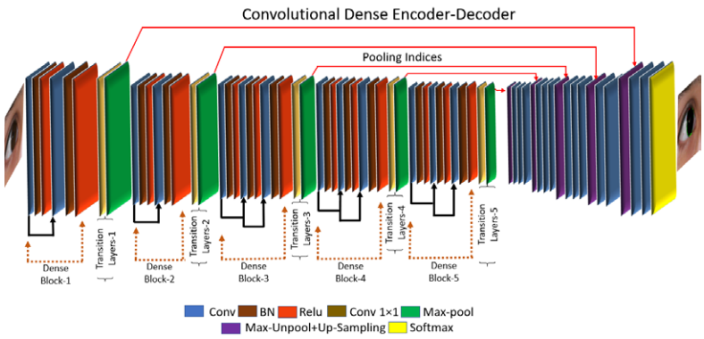
SegNet is a practical fully convolutional network for pixel-wise semantic segmentation, which uses the encoder of a 13-layered VGG16 identical core network with fully connected layers removed. The decoder up-samples the low-resolution input feature maps with pooling indices. In our study, we use the SegNet-Basic decoder. SegNet uses a VGG16 identical network owing to the drawback of overfitting and vanishing gradient. Densely connected convolutional network (DenseNet) is proved to be more robust than VGG-net with better information gradient flow due to dense connectivity. In DenseNet, each convolutional layer is connected to all convolutional layers in a feed-forward fashion, which is very useful for strengthening the feature propagation in the subsequent layers in a dense block. Though this connectivity, IrisDenseNet exploits the network potential through the feature reused from the previous layer, which results in enhanced efficiency. Direct connection is basically the feature concatenation achieved by concatenation layers with multiple inputs and one output. one dense block separately, and includes the basic convolutional layers (Conv), batch normalization (BN) and rectified linear unit (ReLU), which includes the connections of the layers via concatenation. The pooling indices that are provided after each dense block by max-pooling in the transition layer in the decoder part. These pooling indices are used to un-pool and up-sample for pixel-wise semantic segmentation of iris and non-iris boundaries.
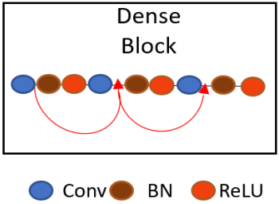
Dense connectivity within the dense block by feature concatenation
1.11.1. IrisDenseNet Dense Encoder
Owing to the advantages of dense connectivity, this study is based on a densely connected encoder in which five dense blocks are used to improve the performance. Finally, with the SegNet decoder, a densely connected convolutional network for iris segmentation (IrisDenseNet) is created. The IrisDenseNet dense encoder consists of 18 convolutional layers, including five 1 × 1 Conv layers used as the bottleneck layer in transition layers after each dense block, which is useful in reducing the number of input feature maps for computational efficiency. the complete dense connectivity with the operation of transition layers. The transition layers are basically a combination of Conv 1 × 1 and max-pooling, separate two adjacent dense blocks. The IrisDenseNet have the following five key differences compared to DenseNet.
- DenseNet is using 3 dense blocks for CIFAR and SVHN datasets and 4 dense blocks for ImageNet classification whereas IrisDenseNet uses 5 dense blocks for each dataset.
- In DenseNet, all dense blocks have four convolutional layers , whereas IrisDenseNet has two convolutional layers in the first two dense blocks and 3 convolutional layers for the remaining dense blocks.
- In IrisDenseNet, the pooling indices after each dense block are directly fed to the respective decoder block for the reverse operation of sampling.
- In DenseNet, fully connected layers are used for classification purpose, but in order to make the IrisDenseNet fully convolutional, the fully connected layers are not used.
- In DenseNet, the global average pooling is used in the end of the network whereas in IrisDenseNet, global average pooling is not used to maintain the feature map for decoder operation.
The dense connectivity has following advantages over simple connections:
- It substantially reduces the vanishing gradient problem in CNNs, which increases the network stability.
- Dense connectivity in the encoder strengthens the features flowing through the network.
- It encourages the feature to be reused due to direct connectivity, so the learned features are much stronger than those of normal connectivity.
A detailed layer-wise structure is provided in better understanding, which shows that in a dense block, due to feature map concatenation, the output feature size for all layers in a corresponding dense block always remains the same, which guarantees strong features. the features through the red and half-circle lines (including arrows) in each dense block are concatenated with the output features of convolution layer, and this concatenation layer is implemented by depth Concate nation Layer() function.
1.11.2. IrisDenseNet Decoder
The SegNet-Basic decoder is used to up-sample the dense feature provided by the dense encoder in this study. The decoder basically utilizes the pooling indices along with dense features, and the feature maps are again passed through convolution filters for a reverse process to the encoder to obtain the segmentation mask with same size as that of the input. In the end, each pixel is classified by the soft-max function independently as iris or non-iris via the pixel classification layer.
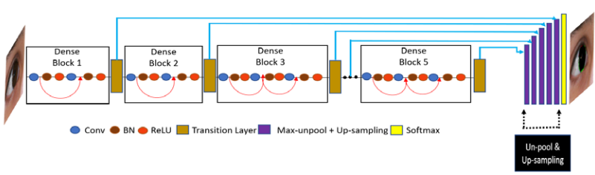
Overall connectivity diagram of IrisDenseNet dense encoder–decoder
1.12 ETDS: Eye Tumour Detection System
In eye tumour detection system (ETDS), image processing techniques have been applied in order to enhance the eye tumour images. Initially, the original image has been converted to grayscale in order to minimise the CPU time, followed by image filtering in order to remove excess data within the image. Afterwards, image enhancement technique is applied to prepare processed image for image subtraction. Canny edge detection has been applied in segmentation step for image fusion. Following images are samples from the original image database, without any image processing techniques are applied.
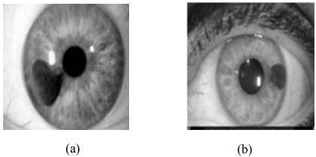
Original sample database images
1.12.1. Image Filtering
Smoothing, which is also known as blurring, is an image processing technique that reduces the noise in an image to produce meaningful image for future step. Most smoothing techniques are based on low pass linear filters. In order to perform a smoothing operation, a filter is applied to an image. The most common type of filters is the linear filters. Median filter is a type of linear filters9 . Median filter is used to reduce impulsive noise in an image with preserving the useful features and image edges. Median filtering is a linear process in which the output of the being processed pixel is found by calculating the median of a window of pixels that surrounds that studied pixel10. In other words, the median filter goes through each element of the image and replaces each pixel with the median of its neighbouring pixels which are located in a square neighbourhood (kernel) of 3*3 pixels around the evaluated pixel.
1.12.2. Morphological operations
Morphology operations are grouped as image processing procedures that apply an organising component to an input,to produce the output image11. The structure element is a matrix consists of 0's and 1's, where the 1's are called the neighbours. The value of each pixel in the output image is set according to a comparison of the corresponding pixel in the input image with its neighbours. It has many shapes according to its application. In order to extract the background of the image, the “disk” structure element with a “radius” of 10 is used. The most common and basic morphological operations are dilation and erosion. Dilation is to add pixels to the boundaries of objects in an image, while erosion is to remove pixels on object boundaries. The number of pixels that are added or even removed from the structure in an image depends on the size and shape of the structuring element that is used to process that image. In these morphological operations (dilation and erosion), the condition of any given pixel in the output image can be determined by applying a rule to the studied pixel and its neighbours in the input image12. A filter is applied to images for performing a smooth operation. As stated above, median filter is used to reduce impulsive noise with preserving the useful features and edges. This technique can be defined as erosion followed by dilation using the same structure element for the two morphological operations. In this technique the objects that cannot completely contain the structuring element are removed in order then for the background to be to extracted14.
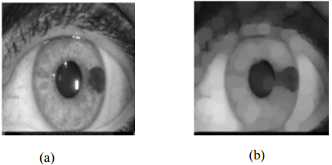
(a) Median filtered image; (b) Eroded image
1.12.3. Image Addition
This technique results in a brighter image. Image addition is used to designed system to clear and brighten the tumour area by adding more pixels to image in the designed system. This technique is to add the extracted background image to the original image which results in a brighter and enhanced image.
1.12.4. Image Adjustment
Image adjustment is increasing the image intensity and its quality. This image processing technique intends to improve the quality and brightness of the image by expanding the intensity of its pixels. This is done by changing the contrast or brightness of an image. In this procedure, pixel values below a specified value are displayed as black and pixel values above a specified value are displayed as white, and pixel values in between these two values are displayed as shades of grey. The result is a linear mapping of a subset of pixel values to the entire range of greys, from black to white, producing an image of higher contrast 15. As it can be seen from the below, the image adjustment operation has a great effect in enhancing the contrast and brightness of the image, so it is clearer and its region of interest (tumour) is brighter and seen. This helps to detect the edges and the tumour area of the image in the next process.
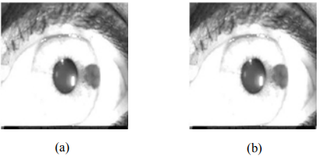
(a) Image addition; (b) Adjusted image
1.12.5. Edge Detection Based Segmentation
The main goal of image segmentation is partition the image into regions. This technique is a meaningful method in medical imaging, in particularly for tumour and lesion extraction and segmentation. In the image segmentation, in view of a semantic object, striking and useful regions are considered. This is the principle issue for image segmentation in light of region of interest16. Pixel edges are associated with some intensity changes or discontinuities; therefore, edge detection is the process of identifying such sharp intensity contrasts in an image12. In this proposed system, edges are detected by using canny operators. This technique is the most common method for detecting edges and segmentation. The Canny edge detector provides good noise immunity and detects the true edges or intensity discontinuities while preserving a minimum error17. The canny edge technique is an image segmentation approach that uses a gradient magnitude of the pixels in an image. An edge is detected if its gradient magnitude is greater than that of its left and right neighbour's pixels17.
1.12.6. Image Fusion
Image fusion is the procedure of consolidating pertinent data from two or more images into a solitary image that is more informative than any of the first images. Image fusion can be arranged into three classes: pixel level, feature level, and decision level18. In pixel level fusion, the information images are combined pixel by pixel after the data extraction. In order to actualize the pixel level fusion, a number of arithmetic operations are utilized as a part of time domain. Frequency transformations changes are utilized as a part of frequency domain. The primary objective of pixel level fusion is to upgrade the crude information images and furnish a yield image with more helpful data than either include image. Pixel level fusion is viable for fantastic crude images however not suitable for images with uneven quality level in light of the fact that data from one physical channel may be blocked by the other. In the designed ETDS system the pixel level image fusion is used in order to superimpose the edge detected and segmented image with the original grayscale one, so that the system automatically detects any tumours or abnormalities in an eye image.
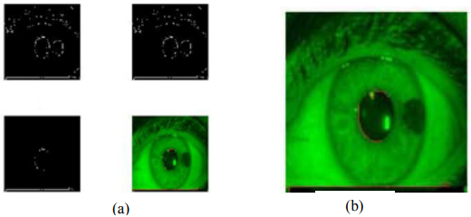
(a) Segmented image; (b)Fused image
1.13. IETDS: Intelligent Eye Tumour Detection System
Intelligent Eye Tumour Detection System (IETDS) uses two conventional 3-layer back propagation neural networks (BPNN) with 4096 input neurons. Output neurons classify the organs using binary coding: [1 0] for the Organ with tumour, and [0 1] for the Organ without tumour. The sigmoid activation function is used for activating neurons in the hidden and the output layers. Figure 5 shows the topology of the suggested BPNN. Due to the implementation simplicity, and the availability of sufficient “input – target” database for training, the use of a back propagation neural network which is a supervised learner, has been preferred. Figure 5a and 5b represent BPNN1 and BPNN2 respectively. Training and testing (generalization) are comprised for this phase. The available eye image database is organized as follows:
- Training image set: 30 images
- Testing image set 1: 70 images
During the learning phase, initial random weights of values between -0.4 and 0.4 were used. In order to achieve the required minimum error value and meaningful learning, the learning rate and the momentum rate were adjusted during various experiments. An error value of 0.002 was considered as sufficient for this application. Table 3and 4 show the final parameters of the trained network.

1.14 MODULES
IRIS IMAGE ACQUISITION
In this paper, we proposed an embedded iris recognition system based on ARM. Considering the requirements of iris image acquisition and recognition algorithm, we analyzed the design method of the iris image acquisition module, designed the ARM processing module and its peripherals, studied the Linux platform and the recognition algorithm based on this platform, finally actualized the design method of ARM-based iris imaging and recognition system.
LOCALIZATION AND NORMALIZATION IN IMAGE
The normalization module is integrated into our complete system for knowledge based visual exploration of scenes. It should be highlighted that, to the best of our knowledge, this is the first time that a new BN module has been developed for the facial landmark localization task. we can see that the tracking parameters of all the three BN branches in any SepBN module are highly similar to each other throughout the whole network, indicating that separating the normalization step is unnecessary. The new tensor is flattened and used as the input of a Multi-Layer Perceptron module, followed by a temperature-controlled softmax function. At last, using the generated attention weights, the appropriate scale and shift parameters for each group of channels of each sample can be obtained.
IMAGE ENHANCEMENT:
The Image Enhance module contains a number of classes that can be used for image enhancement. An image enhancement module used for improving the quality of images using different filters in open CV. It works better with gray-scale images. The filters used are median filter for removing noise from the image, The histogram equalizer is used for contrast adjustment of the image and Gamma correction is also applied for preventing the image from darkening.
FEATURE EXTRACTION IN IMAGE:
Feature extraction refers to the process of identifying and combining certain features of patterns. Given a collection F of features, the extracted features are linear/non-linear combinations of elements of F. This is a pre-processing step of pattern recognition. Before pattern classification is carried, it is necessary to decide what attributes of the patterns are to be measured and recorded. The features chosen should be discriminating features of the pattern. It is an important stage of pre-processing, as the feature extraction influences the quality of the pattern classification carried out.

CHAPTER 2

LITERATURE SURVEY

TITLE | AUTHOR | DESCRIPTION
Congenital iris cysts | Richard D Grutzmacher, Thomas D Lindquist, Mark E Chittum, Ann H Bunt-Milam, And Robert E Kalina, | Unilateral, spontaneous, non-pigmented iris cysts appeared before the age of 2 years in four patients. Histopathological specimens obtained in three cases showed stratified to cuboidal, non-pigmented, epithelial lined cysts.
A Spatial Median Filter for Noise Removal in Digital Images | James Church, Dr. Yixin Chen, and Dr. Stephen Rice, | The purpose of these algorithms is to remove noise from a signal that might occur through the transmission of an image.
Retinal Image Analysis Using Morphological Process and Clustering Technique | R.Radha and Bijee Lakshman, | This paper proposes a method for the Retinal image analysis through efficient detection of exudates an d recognizes the retina to be normal or abnormal.
Image Segmentation of Blood Cells in Leukemia Patients | Khashman, A., Al-Zgoul, E., | We propose the use of morphological analysis of microscopic images of leukemic blood cells for the identification purpose.

2.1 EXISTING SYSTEM

- The survey of various existing techniques provides a platform for the development of the novel techniques in this area as future work.
- Existing iris recognition systems are heavily dependent on specific conditions, such as the distance of image acquisition and the stop-and-stare environment, which require significant user cooperation.
- Most existing iris recognition algorithms are designed for highly controlled cooperative environments, which is the cause of their failure in non-cooperative environments, i.e., those that include noise, off-angles, motion blurs, glasses, hairs, specular reflection (SR), eyelids and eyelashes incorporation, and partially open eyes.
- If the dark pixel exists inside the box because the dark pupil can be included in the box, the box position is adaptively moved into the lower direction until it does not include the dark pixel, and the average RGB value is extracted box.
- When applying CNN, false positive errors (non-iris pixel is incorrectly classified into iris pixel) exist in the pupil area.

2.1.1 Disadvantages of existing system

- Iris DenseNet is an end-to-end segmentation network that uses the complete image without prior pre-processing or other conventional image processing techniques with the best information gradient flow, which prevents the network from overfitting and vanishing gradient problem.
- To address the issues of accurate segmentation without prior pre-processing and to develop a robust scheme for all types of environments, this study presents a densely connected fully convolutional network (IrisDenseNet)-based approach to detect an accurate iris boundary with better information gradient flow due to dense connectivity.
- To address the iris segmentation issues in challenging situations by visible light and near-infrared light camera sensors, this paper proposes a densely connected fully convolutional network (IrisDenseNet), which can determine the true iris boundary even with inferior-quality images by using better information gradient flow between the dense blocks.

2.2 PROPOSED SYSTEM
- To address this issue, we proposed a two-stage iris segmentation method based on convolutional neural networks (CNN), which is capable of robustly finding the true iris boundary in the above-mentioned intense cases with limited user cooperation.
- Our proposed iris segmentation scheme can be used with inferior quality noisy images even in visible light environment.
- The proposed method accurately identified the true boundary even in intense scenarios, such as glasses, off-angle eyes, rotated eyes, side view, and partially opened eyes.
- We proposed a CNN-based segmentation method of the iris region based on the ROI defined by the rough iris boundary.
- Our proposed method can correctly segment the iris region irrespective of various noises in eye image.
2.2.1 Advantages of proposed system
- The major challenge here is to achieve high performance on a mobile platform because of limitation of space, power, and cost of the system.
- IrisDenseNet is a densely connected fully convolutional network that proceeds in the feed-forward fashion with dense features for better performance.
- This connectivity enhances the capability of the network and enables the feature reuse for better performance.
- Biometrics in both physiological and behavioral forms are delivering an efficient platform for security metrics.
- We would optimize the network further and reduce the number of layers to make it memory-efficient for mobile and handheld devices with reduced parameters and multiplications.
- Iris recognition shares the following advantages of secure biometrics: iris features are unique even in the case of twins, left eye iris features of an individual are different from right eye iris features, iris features are naturally complex to be created artificially, and iris features are permanent and remain same throughout a human’s lifespan

2.3 FEASIBILITY STUDY

The feasibility of the project is analyzed in this phase and business proposal is put forth with a very general plan for the project and some cost estimates. During system analysis the feasibility study of the proposed system is to be carried out. This is to ensure that the proposed system is not a burden to the company. For feasibility analysis, some understanding of the major requirements for the system is essential.

Three key considerations involved in the feasibility analysis are:

- Economical feasibility

- Technical feasibility

- Operational feasibility

2.3.1 Economical Feasibility

This study is carried out to check the economic impact that the system will have on the organization. The amount of fund that the company can pour into the research and development of the system is limited. The expenditures must be justified. Thus the developed system as well within the budget and this was achieved because most of the technologies used are freely available. Only the customized products had to be purchased.

The economic feasibility based on the terms of:

- Time

- Cost

- Man power

2.3.2 Technical Feasibility

This study is carried out to check the technical feasibility, that is, the technical requirements of the system. Any system developed must not have a high demand on the available technical resources. This will lead to high demands on the available technical resources. This will lead to high demands being placed on the client. The developed system must have a modest requirement, as only minimal or null changes are required for implementing this system.

2.3.3 Operational Feasibility

The aspect of study is to check the level of acceptance of the system by the user. This includes the process of training the user to use the system efficiently. The user must not feel threatened by the system, instead must accept it as a necessity. The level of acceptance by the users solely depends on the methods that are employed to educate the user about the system and to make him familiar with it. His level of confidence must be raised so that he is also able to make some constructive criticism, which is welcomed, as he is the final user of the system.

CHAPTER 3

SYSTEM SPCIFICATION

3.1 HARDWARE REQUIREMENTS:

- Keyboard
- Mouse
- Hard disk 500GB
- Ram 4 Gb
3.2 SOFTWARE REQUIREMENTS:

- Operating System : Windows 10
- Language : Arduino UNO C++

CHAPTER 4

SYSTEM DESIGN AND DEVELOPEMENT
DATA FLOW DIAGRAM

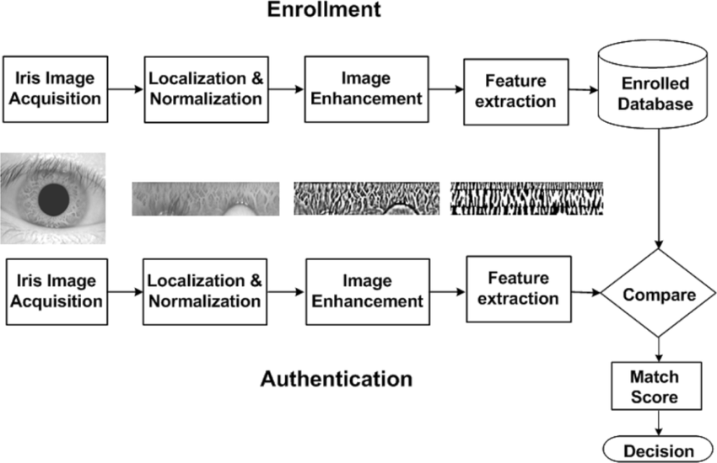

CHAPTER 5

TESTING AND IMPLEMENTATION
  - TESTING
Implementation is the stage of the project when the theoretical design is turned into a working system. This is the final and important phase in the system life cycle It is actually the process of converting the new system into a operational one.
5.1.1Unit Testing
Unit testing comprises the set of tests performed by an individual programmer prior to integration of the unit into a larger system. The module interface is tested to ensure that information properly flows into and out of the program unit. The local data structure is examined to ensure that data stored temporarily maintains its integrity during all steps in an algorithm’s execution. Boundary conditions are tested to ensure that the module operates properly at boundaries established to limit or restrict processing. All independent paths through the control structure are tested. All error-handling paths are tested.
5.1.2 Block Box Testing
Black-box testing is a method of software testing that examines the functionality of an application without peering into its internal structures or workings. This method of test can be applied virtually to every level of software testing: unit, integration, system and acceptance. It is sometimes referred to as specification-based testing.
5.2 SYSTEM IMPLEMENTATION
Implementation is the stage of the project when the theoretical design is turned into a working system. This is the final and important phase in the system life cycle It is actually the process of converting the new system into a operational one.

CHAPTER 6
CONCLUSION
CONCLUSION
This paper presented a novel approach for the detection of the iris tumor using segmentation and image fusion. The developed system reads the tumorous iris image, processes it, and marks the regions of interest (tumorous regions) including pupil for the affected images. However, for the normal images, only pupils are marked since there are no tumors into the iris. The system has been tested for normal and abnormal images obtained from Miles Research and the experimental results were successful which proves that our effective system can be implemented into real life applications.

REFERENCES

[1] Heath grades, “Eye Cancer”, available: http://www.healthgrades.com/conditions/eye-cancer.

[2] Richard D Grutzmacher, Thomas D Lindquist, Mark E Chittum, Ann H Bunt-Milam, And Robert E Kalina,” Congenital iris cysts”. British Journal of Ophthalmology, 1987, 71, p.p. 227-234H.

[3] Cancer Research UK, available: http://www.cancerresearchuk.org/about-cancer/type/eyecancer/about/types-of-eye-cancer#mel

[4] The Eye Cancer Foundation Eye Cancer Network Education and Support for Eye Tumor Patients and Their Families, available: http://www.eyecancer.com/conditions/34/irismelanoma

[5] Miles Research, available: http://www.milesresearch.com/main/links.htm.

[6] Digital image processing, available: http://www.tutorialspoint.com/dip/Grayscale_to_RGB_Conversio n.html.

[7] James Church, Dr. Yixin Chen, and Dr. Stephen Rice, “A Spatial Median Filter for Noise Removal in Digital Images”. Southeastcon, 2008. IEEE, p.p.618 – 623.

[8] R.Radha and Bijee Lakshman, “Retinal Image Analysis Using Morphological Process and Clustering Technique”. Signal & Image Processing: An International Journal (SIPIJ) Vol.4, No.6, December 2013.

[9] Ms. M. Parisa Beham, Ms.A.B.Gurulakshmi, Morphological Image Processing Approach on The Detection of Tumor and Cancer Cells. Devices, Circuits and Systems (ICDCS), 2012 International Conference, 2012, p.p. 350 – 354.

[10] Gonzalez and Woods, Digital Image Processing, Second Edition, PrenticeHall, pp. 108-120, 2002

[11] Khashman, A., Al-Zgoul, E., “Image Segmentation of Blood Cells in Leukemia Patients”. Recent Advances in Computer Engineering and Application, 2010 pp. 104–109.

[12] Xie Mei, Zhen Zheng, Wu Bingrong, Li Guo, The Edge Detection ofBrain Tumor. “Communications, Circuits and Systems”. ICCCAS 2009. International Conference. 2009.pp. 477-479.

[13] Lijun Ding, Ardeshir Goshtasby, “On the Canny edge detector”. Pattern Recognition Society, 2001. p.p.721-725.

[14] Z. Zhang and R. S. Blum, “Region-Based Image Fusion Scheme for Concealed Weapon Detection”. Proceedings of the 31st Annual Conference on Information Sciences and Systems, 1995.

[15] J. Lanir, et al., “Comparing multispectral image fusion methods for a target detection task”. Optical Engineering, vol. 46, pp. 66402-1, 2007.

